EEE088F 2021

Assignment2

**Q1 Power supply subsystem [30]**

**Q1.1 [10]**

**Q1.2 [5]**

**Q1.3 [10]**

**Q2 Amplifier [30]**

**Q2.1 [10]**

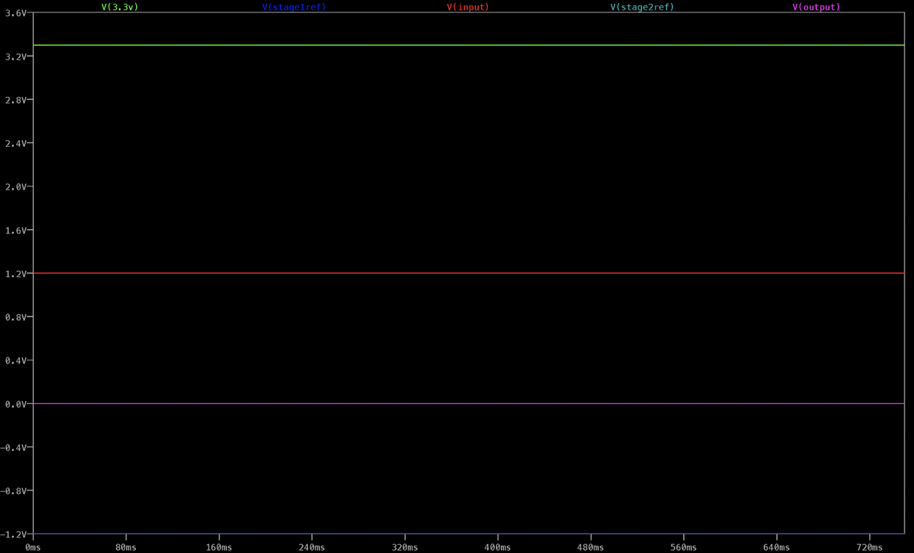Running Simulations of Amplifier subsystem of Irrigation PiHAT

Figure 2.1.1

Amplifier circuit simulation displaying the output Voltage of the circuit yielded from a constant 1,2 V input V(input). This input provides a means for simulating the lower bound of the input voltage received from the soil moisture level sensing circuit.

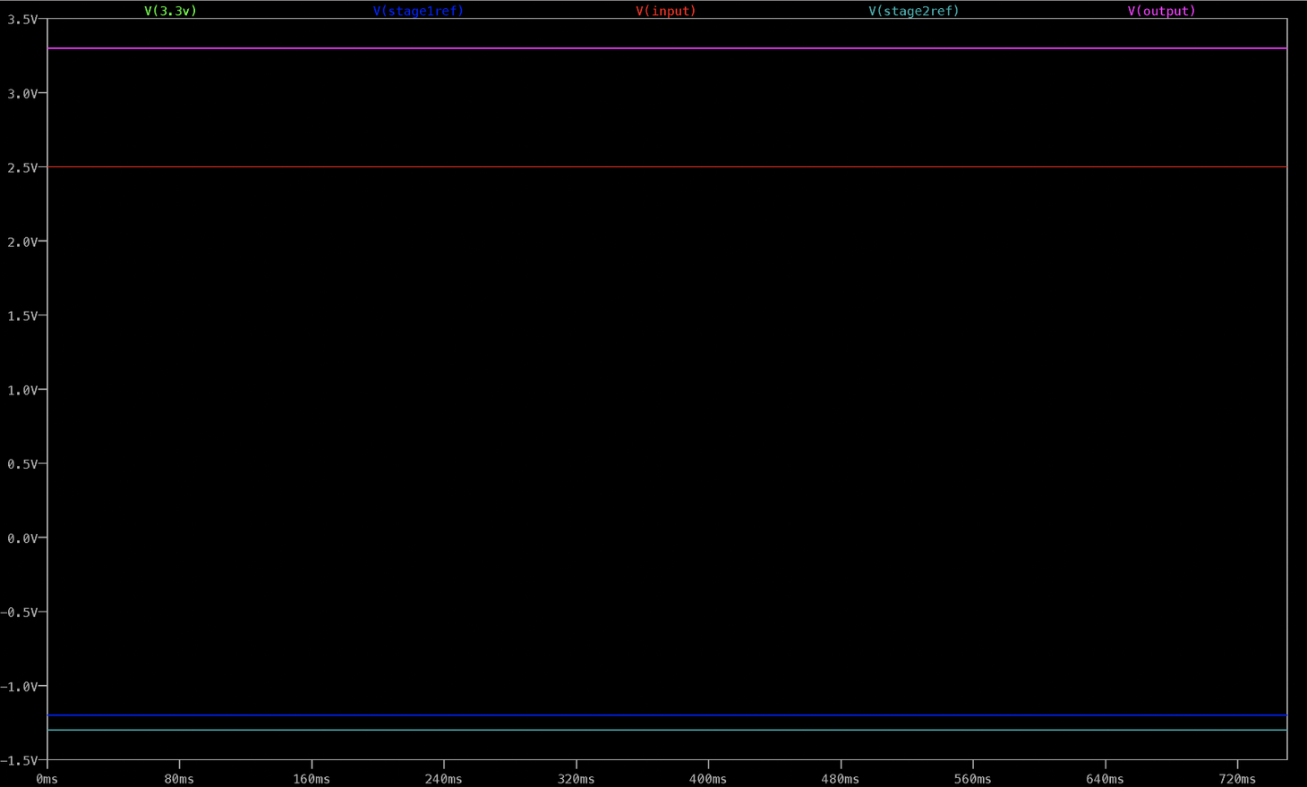

Figure 2.1.2

Amplifier circuit simulation displaying the output Voltage of the circuit yielded from a constant 2,5 V input V(input). This input provides a means for simulating the upper bound of the input voltage received from the soil moisture level sensing circuit. At this input voltage, the output of this sub-system V(out) is the maximum output of 3,3V Vout(3.3V).

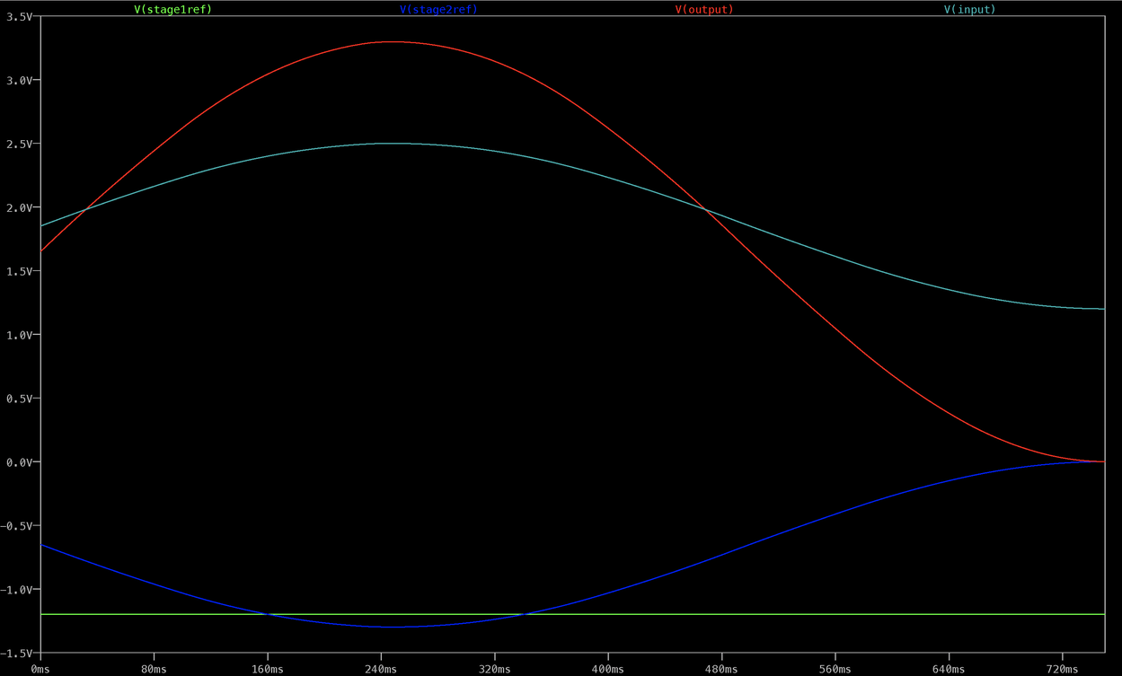

Figure 2.1.3

Amplifier circuit simulation displaying the output Voltages of the circuit yielded from a sinusoidal input V(input). This input provides a means for simulating the various voltage inputs received from the soil moisture level sensing circuit depending on the possible soil moisture levels.

**Q2.2 [5]**

Circuit diagrams of Amplifier subsystem of Irrigation PiHAT

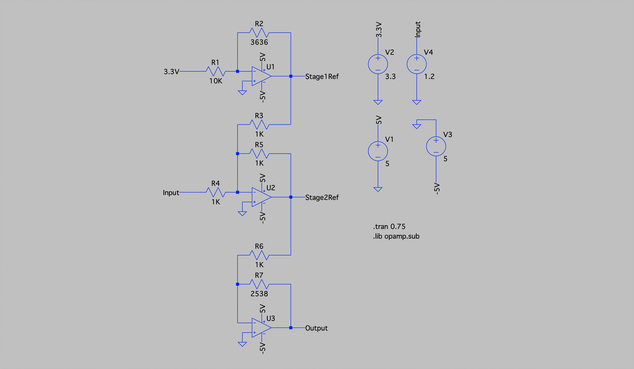

Figure 2.2.1

Amplifier circuit with an input Voltage yielded from a constant lower bound 1,2 V input V(input).

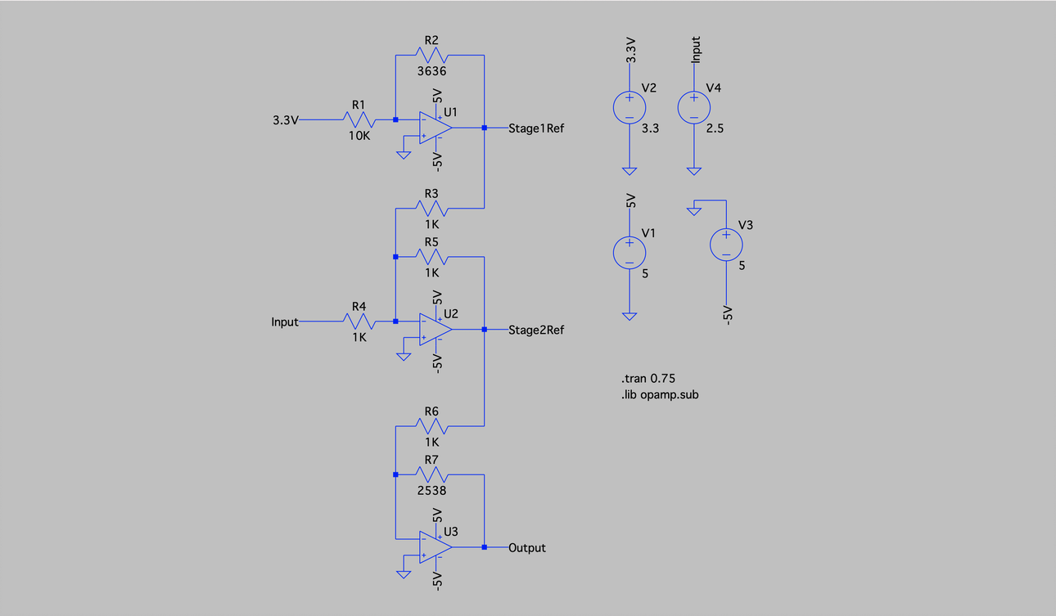

Figure 2.2.2

Amplifier circuit with an input Voltage yielded from a constant upper bound 2,5V input V(input).

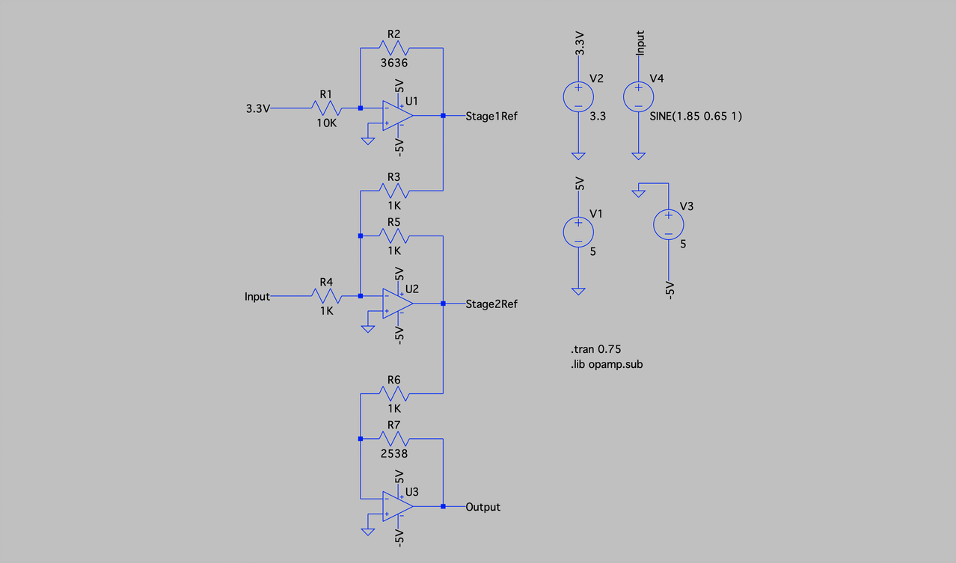

Figure 2.2.3

Amplifier circuit with an input Voltage yielded from a time-varying sinusoidal input V(input).

**Q2.3 [10]**

The three stages of op amps are connected to each other, with U3 providing the amplified output that will interface with the LED comparators and manual comparator subsystems.

The input to the amplifier subsystem comes in the form of an analogue signal from the moisture sensors, in the range of 1.2V to 2.5V

The output of the subsystem involves an adjusted analogue signal which is scaled to be between 0V and 3.3V to match the Raspberry Pi’s output rails

The LM324D op amp was chosen for this circuit as it is a quad op amp, which means it is a 4-in-1 integrated circuit, and therefore is more space-efficient on a PCB. Additionally, this op amp is a Surface-Mount Device, further saving space on the PCB.

**Q2.4 [5]**

Yes, the circuit simulated meets the specifications for this subsystem, as follows:

Stage 1: The inverting op amp U1 amplifies a 3.3V input voltage to –1.2V to be used in Stage 2.

Stage 2: Consists of a summing amplifier op amp U2. The input signal of 1.2-2.5V is summed with the –1.2V to achieve a 0-1.3V output to be used in stage 3.

Stage 3: The inverting op amp U3 amplifies Stage 2’s output to a value between 0V and 3.3V as required.

**Q3 Status LEDs and Valve Control [20]**

**Q3.1 [5]**

Running Simulations of LED and Valve Control subsystem of Irrigation PiHAT

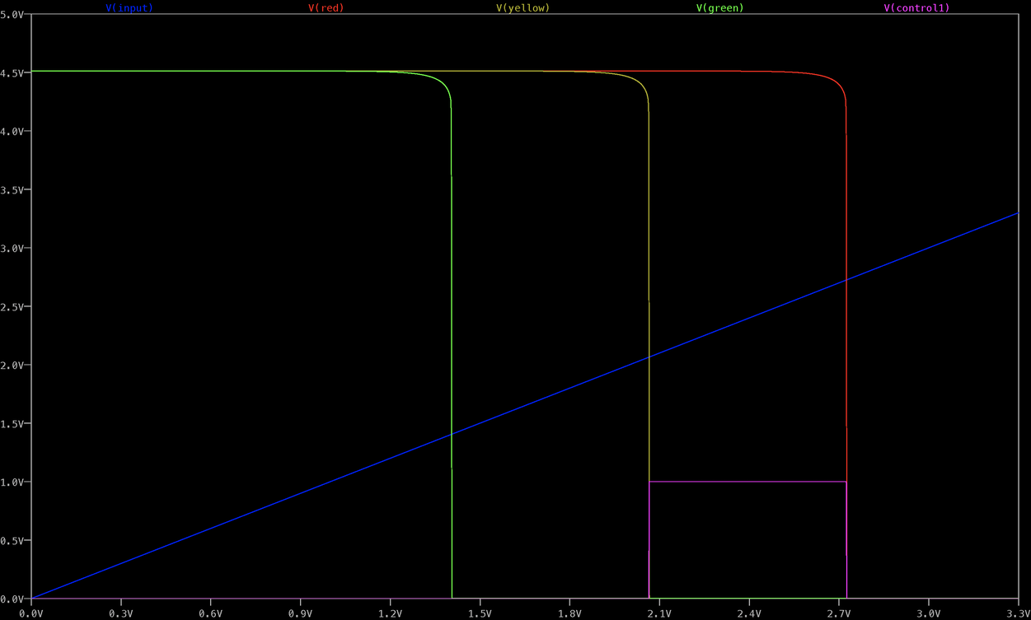

Figure 3.1.1

LED circuit simulation displaying:

1. A simulated input Voltage V(in) ranging from 0V (very moist soil) to 3,3V (very dry soil).
2. The adjustable trigger Voltages of the comparators V(red), V(yellow) and V(green) for the respective coloured LEDs, indicating at what input voltage these comparators turn on (consecutively).
3. An additional potentiometer-dependent voltage V(control) that can be adjusted by the PiHat user, to manually control the valves and bypass the soil moisture sensors.

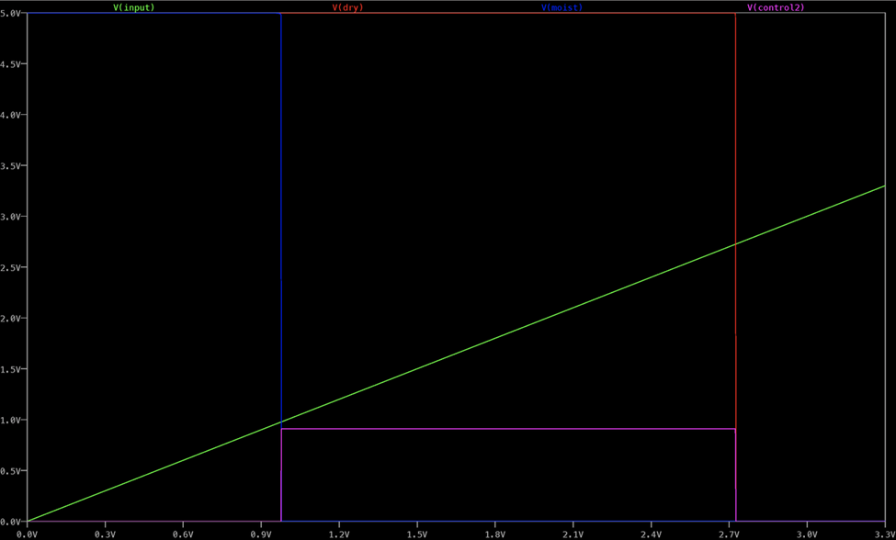

Figure 3.1.2

Valve control circuit simulation displaying:

1. A simulated input Voltage V(in) ranging from 0V (very moist soil) to 3,3V (very dry soil).
2. The adjustable trigger Voltages of the comparators V(dry) and V(moist), in the case that the user does not want to use the LED subsystem.
3. An additional potentiometer-dependent voltage V(control2) that can be adjusted by the PiHat user, to manually control the valves and bypass the soil moisture sensors.

**Q3.2 [5]**

Circuit diagram of LED and Valve Control subsystem of Irrigation PiHAT

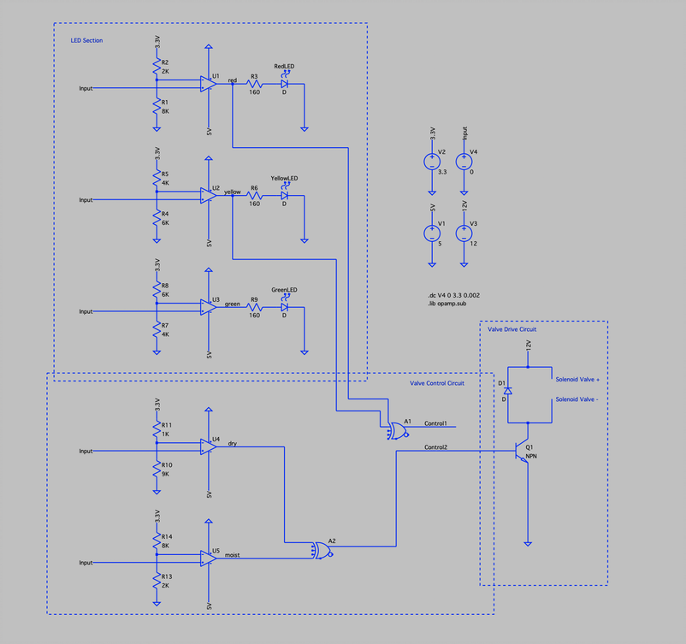

Figure 3.2.1

LED and Valve Control circuit, visually divided into the “LED Section”, “Valve Control Circuit” and “Valve Drive Circuit” circuity.

Note: Control 1 and 2 indicate the action of physical switch control, as this cannot be simulated on LTSpice. The Valve Drive Circuit demonstrates the result of triggering Control 1 and 2 (i.e. the switches).

**Q3.3 [5]**

The inputs to the comparator subsystems come in the range of 0V to 3.3V as an analogue input signal. This signal is received from the amplifier subsystem. When each comparator’s input voltage exceeds the set threshold voltage, the LEDs sequentially turn on.

The outputs of the comparators additionally enter the Raspberry Pi to provide optional data for users to read in. These outputs will vary between a high or low state as outputted by the Op-Amps. Essentially, the Raspberry Pi will read the LED state.

There is an override switch present between the LED and valve control circuit, as a means to manually control the valve control values.

There is an internal subsystem which provides the user of the HAT to switch the output interface configuration using a pin jumper.

The output is an analogue signal and can be drawn from either the LED comparator system or by a potentiometer adjustable circuit.

The LED resistor values (160 Ohms) were determined from ( 5V-1,8V / 20mA), where 20mA is the operating current of the LED.

**Q3.4 [5]**

Yes, the circuit simulated meets the specifications for this subsystem, as follows:

1: Three comparator circuits present, with each threshold voltage controlled by a potentiometer.

2: There are two circuits present to determine the valve control system, namely two additional comparators for when the valve turns off and on, as well as logic gates to ensure the valves turn on at the required values.

**Q4 Simulation as a design stage [5]**

The LED subsystem simulation results changed the circuitry of the comparators, which were originally designed with a 5V Vcc and 0V Vss, wherein the Vcc and Vss values had to be swopped for the simulation to correctly display the sequential triggering of the LEDs.

Other subsystems confirmed that our designs were done correctly.

**Q5 Upload simulation files**

Upload a zip file containing the Spice project files for all above simulations to Vula or provide a link to a git repository containing these files. Eventually you will be putting these into a public git repository, if you would like to do that now already please provide the url to that repository in this submission here instead.

Delete whichever is not applicable:

● Simulation files uploaded to Vula

● Simulation files available at this publically accessible git repository url: